Hurricane Florence Coastal Georgia, 1851 to 2020 Topobathymetric Digital Elevation Model (TBDEM)
Spatial Metadata

Data Delivery Overview:
The geospatial data delivery consists of both an Esri File Geodatabase and OGC Geopackage of Georgia (GA) with file extension *.gdb and *.gpkg respectively. The database(s) “Topobathymetric_Model_of_Coastal_Georgia_1851_to_2020_Spatial_Metadata.*” are geospatial polygon (Figure 1) feature datasets that contain spatial footprints for each input source dataset (Table 1). The attributes for each footprint polygon describe the characteristics of each input dataset used to generate the TBDEM. Detailed descriptions of the coordinate system, survey accuracy, and geodatabase attribute fields are contained in following sections of this document.
Table 1: Polygon Geodatabase Datasets Summary
Geodatabase | Layer Type | Number of Polygons+
Topobathymetric_Model_of_Coastal_Georgia_1851_to_2020_Spatial_Metadata.* | Multipart Polygon | 16

Horizontal Coordinate System:
Transverse Mercator
NAD 1983 (2011) UTM Zone 17N
Horizontal coordinates are provided in UTM northing/easting.

Attribute Field Data Dictionary (Esri Geodatabase):
Title = Source dataset name
Source_Project = Organization major project or activity
Source_Organization = Source dataset organization
Date_Acquired = Date data were acquired
Source_Publication_Date = Date source data were published
Data_Type = Input elevation type
Source_Projection = Input source projection
Source_Resolution = Input source horizontal resolution
Source_Horizontal_Datum = Input source horizontal datum
Source_Vertical_Units = Input source vertical units
Source_Vertical_Datum = Input source vertical datum
Geoid = Input source geoid
Coverage_Area = General spatial extent description of input source dataset
Source_Publication = Online web link to input source dataset
Shape_Length* = Perimeter length of spatial polygon feature in meters
Shape_Area* = Area of spatial polygon feature in square meters

Example attributes from spatial metadata Esri Geodatabase:
Title = 2018 USACE NCMP Post-Florence Topobathy Lidar (NC, SC, VA)
Source_Project = USACE NCMP
Source_Organization = USACE JALBTCX
Date_Acquired = 2018
Source_Publication_Date = 20190809 (Date format YYYYMMDD)
Data_Type = Topobathy Lidar
Source_Projection = Geographic
Source_Resolution = 1/27 arc-second (~1-m)
Source_Horizontal_Datum = WGS84
Source_Vertical_Units = Meters
Source_Vertical_Datum = NAVD88
Geoid = GEOID12B
Coverage_Area = Southern Coast (VA, NC, SC)
Source_Publication = https://coast.noaa.gov/htdata/lidar1_z/geoid12b/data/
Shape_Length* = 1345963.036692
Shape_Area* = 46842673.186489
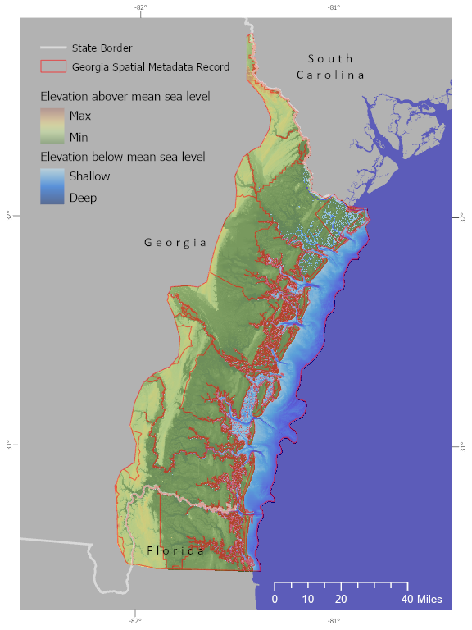
Figure 1: Spatial Metadata (SMD) extent of Hurricane Florence Coastal Georgia, 1851 to 2022 Topoathymetric Digital Elevation Model (TBDEM).

+ There were 36 data sources used to create this TBDEM but the sum of the “Number of Polygons” is greater than that because some individual datasets were used in two or all states
* Inherent Esri Geodatabase geometry attribute

