Topobathymetric Model of the Northern Gulf of Mexico (NGOM2), 1885 to 2021 Spatial Metadata Data Dictionary
Data Delivery Overview:
The geospatial data delivery consists of a geodatabase. The geodatabase “NGOM2_CoNED_TBDEM_Spatial_Metadata.gdb” is a geospatial polygon feature dataset that contains spatial footprints for each input source dataset. The attributes for each footprint polygon describe the characteristics of each input dataset used to generate the TBDEM. Detailed descriptions of the coordinate system, survey accuracy, and geodatabase attribute fields are contained in following sections of this document.
Geodatabase / Polygon Summary (Figure 1):
Geodatabase | Layer Type | Number of Polygons
NGOM2_CoNED_TBDEM_Spatial_Metadata | Polygon | 286

Horizontal Coordinate System:
Transverse Mercator
NAD_1983_2011_UTM_Zone_15N
Horizontal coordinates are provided in UTM northing/easting.

Attribute Field Data Dictionary (Geodatabase):
Title = Source dataset name
Source_Project = Organization major project or activity
Source_Organization = Source dataset organization
Date_Acquired = Date data were acquired
Publication_Date = Date source data were published
Data_Type = Input elevation type
Source_Projection = Input source projection
Source_Resolution = Input source horizontal resolution
Source_Horizontal_Datum = Input source horizontal datum
Source_Vertical_Units = Input source vertical units
Source_Vertical_Datum = Input source vertical datum
Geoid = Input source geoid
Coverage_Area = General spatial extent description of input source dataset
Source_Publication = Online web link to input source dataset
Shape_Length = Perimeter length of spatial polygon feature in meters
Shape_Area = Area of spatial polygon feature in square meters

Attribute Field Data Dictionary (Geodatabase): Example Record
Title = Biloxi, Mississippi Coastal Digital Elevation Model
Source_Project = NCEI Tsunami DEM
Source_Organization = NOAA/NCEI
Date_Acquired = 2007
Publication_Date = 2007
Data_Type = Topobathy
Source_Projection = Geographic
Source_Resolution = 1/3 arc-second
Source_Horizontal_Datum = WGS84
Source_Vertical_Units = Meters
Source_Vertical_Datum = MHW
Geoid = Not documented
Coverage_Area = Biloxi, MS, Mississippi Sound
Source_Publication = https://www.ngdc.noaa.gov/mgg/coastal/coastal.html
Shape_Length = 96139.974089
Shape_Area = 106648238.021328
---------------------------------------------------------------------------------------------------------------------
Note: Any use of trade, product, or firm names is for descriptive purposes only and does not imply endorsement by the U.S. Government.

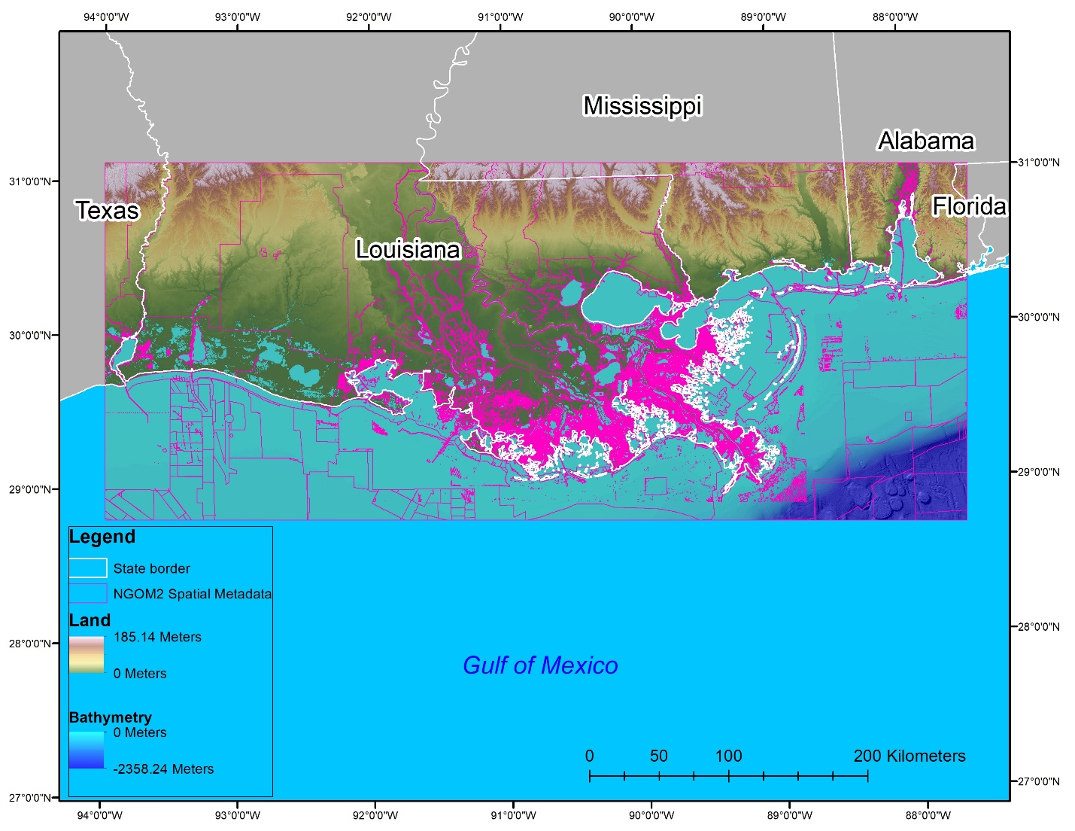

Figure 1: Spatial extent of Topobathymetric Model of the Northern Gulf of Mexico, 1885 to 2021, Topobathymetric Digital Elevation Model, NGOM2 Spatial Metadata polygons – Magenta lines, and State borders – white lines.

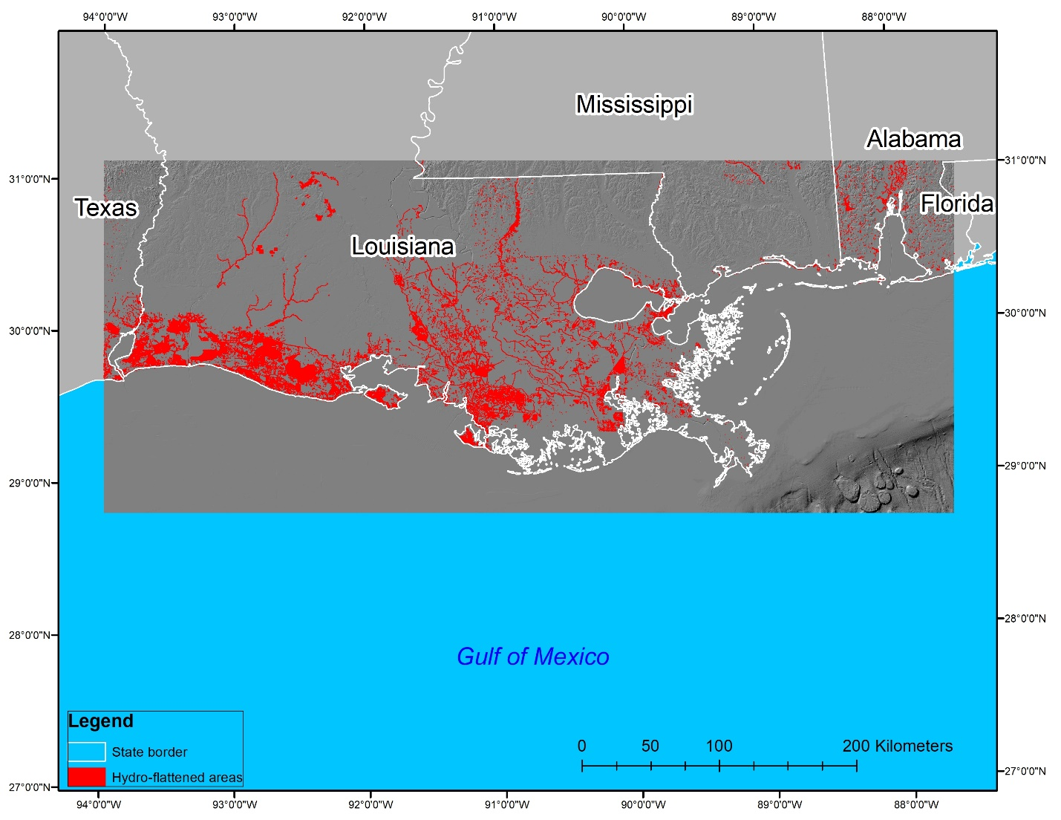

Figure 2: The red polygons represent the hydro-flattened locations in the NGOM2 Topobathymetric Digital Elevation Model. The white lines represent the state boundaries.

